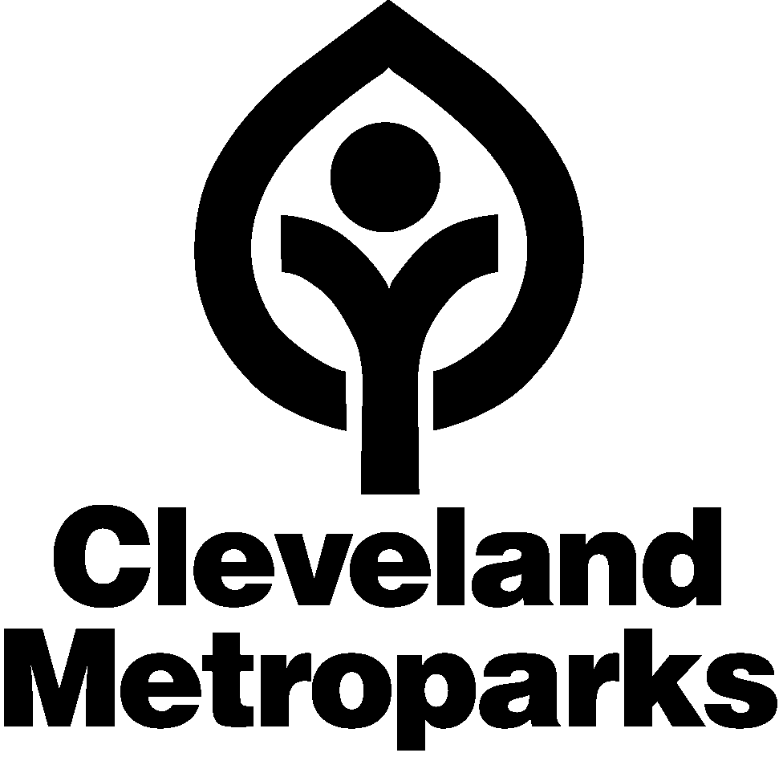
Liability Waiver and Release

Information
Name of Participant: Birth date: ___/___/___ Gender: M □ F □
Parent/Guardian Name (if applicable):
Address:
City, State, Zip:
Phone #: (Home) (cell) (Business)

PLEASE READ & SIGN WAIVER: As part of the consideration tendered for myself (or my child/ward, having not attained the age of 18) being permitted to participate in Voyageur Canoe Paddle, on , 2016 .

I recognize and acknowledge that there are risks associated with the aforementioned program/event, which may include but are not limited to; falls, contact with other participants, the effects of weather, misuse or failure of equipment, drowning or collision with another craft, person, or object in the water. I waive all claims that I might have based on any of those and other risks typical in this type of activity. I am aware staff/volunteers may provide support for this program/event, including but not limited to the administration of: first aid, CPR (Cardiopulmonary resuscitation), or the use of an AED (automated external defibrillator). I authorize any such staff/volunteers to assist me (or my child/ward) and/or to provide such assistance as, in the opinion of such person may be necessary or appropriate. I understand that Cleveland Metroparks, nor any of its supporting sponsors, assume any responsibility or liability with respect to my (or my child/ward) participation in this event/program. I agree and hereby waive (on behalf of myself and my child/ward) all claims against, and agree to fully release, hold harmless, and indemnify Cleveland Metroparks, all sponsors, representatives (including staff/volunteers), and independent contractors from all claims or liabilities of any kind arising out of my participation (or my child/ward’s participation) in this event/program, even though liability may arise out of negligence or carelessness on the part of the persons named in this waiver.

By indicating your acceptance, you understand, agree, warrant and covenant for yourself and, if applicable, for your minor child/ward, as follows (if the participant is under 18 years of age, the parent/guardian must sign).

Signature: Date:

Photo and Video Release

PLEASE READ & SIGN WAIVER: I hereby authorize Cleveland Metroparks to use, reproduce, and/or publish photographs and/or video that may pertain to me (or my child/ward, having not attained the age of 18) — including my (or my child/ward) image, likeness and/or voice without compensation. I understand that this material may be used in various publications, public affairs releases, recruitment materials, broadcast public service advertising (PSAs), multimedia exhibits or for other related endeavors. This material may also appear on Cleveland Metroparks or project sponsor's Internet Web Page and/or digital social media services.

By signing this form, I acknowledge that I have completely read and fully understand the above release and agree to be bound thereby. I hereby release all claims against any person or organization utilizing this material (if the participant is under 18 years of age, the parent/guardian must sign).

Signature: Date:

