Native Plant Purchases

Single Source #6625

Contract period 2022-2023

Native plant material should be utilized for restoration, reforestation, no-mow conversion, pollinator habitats and incorporated into landscape development. The plant material on bid includes bareroot material, shrubs, small and large containerized trees, herbaceous plugs and native seed.

Off Bid Native Plant Orders include 1) Balled & Burlapped landscape trees and 2) Highly ornamental landscapes or horticulture gardens (such as the Zoo) that utilize cultivars of native plants.

This bid is for planting material on our properties. NOT FOR RESALE. The chart below details which type of plant material is available at each nursery; but not limited to:

* **Bareroot Materials**: Clements State Tree Nursery, Vallonia Nursery, Musser Forests
* **Shrubs:** Native Roots, Inc., Woody Warehouse Nursery Inc., and Riverside Native Tree Nursery
* **Containerized Trees**: Woody Warehouse Nursery Inc., Riverside Native Trees
* **Large Trees:** Woody Warehouse Nursery Inc. and QRST Nursey
* **Herbaceous Plugs/ Pots:** Native Roots, Inc., Ohio Prairie Nursery Ltd., Spence Restoration Nursery, Nodding Onion Gardens Native Plant Nursery, Natural Communities LLC, Archewild, and Cardno
* **Native Seed Plant Mix:** Ohio Prairie Nursey Ltd., Natural Communities LLC, Ernst Conservation Seed and Cardno

Plant provenance should originate from within the red boundary below, which can generally be described as the same latitude as the northern border of Ohio, west to the western border of Iowa & Missouri and south and east to the border between Zone 6b & 7a.

**NOTE:** To save on delivery charges, please try to coordinate ordering efforts. Natural Resources typically have at least one spring and one fall order for various restoration projects. If you plan ahead of time, please contact us and we will try to combine delivery trips and save on shipping. (Tim Krynak: [tjk@clevelandmetroparks.com](mailto:tjk@clevelandmetroparks.com))

**ORDERING/PRICING**: All native species in stock within the designated plant material is available for ordering. When creating your requisition please key in the **Purchasing Contract Number 20220013** in the Contract Field. Woody Warehouse will appear in the vendor field. If you need to purchase from another vendor simply key in their vendor number or type in the vendor name. Please keep in mind if you are purchasing native plant material from a nursery that is not currently on bid, you will need to set up a new vendor account with that nursery first. Also, pricing between nurseries and even by species can be variable. When placing the order please give the vendor your PO number. See example below.

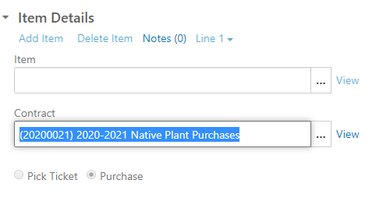

**What appears when you enter 20220013**

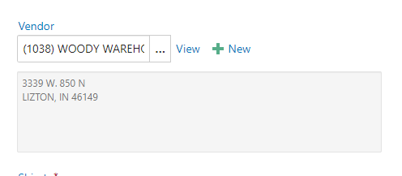

**Keying in different vendor.**

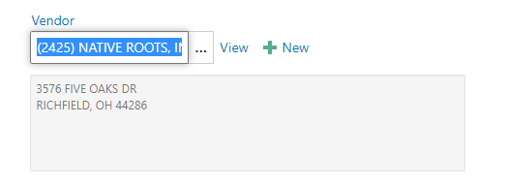

Contact information for nurseries on bid, but not limited to:

